2.17 Fetch Data from CSV and JSON

This section will guide you to understand:

* How to get data from CSV file
* How to get data from JSON file

**Development Environment**

* Postman
* Endpoint URL

This guide has four subsections, namely:

* + 1. Creating a new request and setting the environment
    2. Getting the data from CSV file
    3. Getting the data from JSON file
    4. Pushing the code to your GitHub repositories

**Step 2.17.1:** Creating a new Request and setting the environment

* Go to Postman
* Click on the **New** menu. Choose **Request as** https://reqres.in/api/register

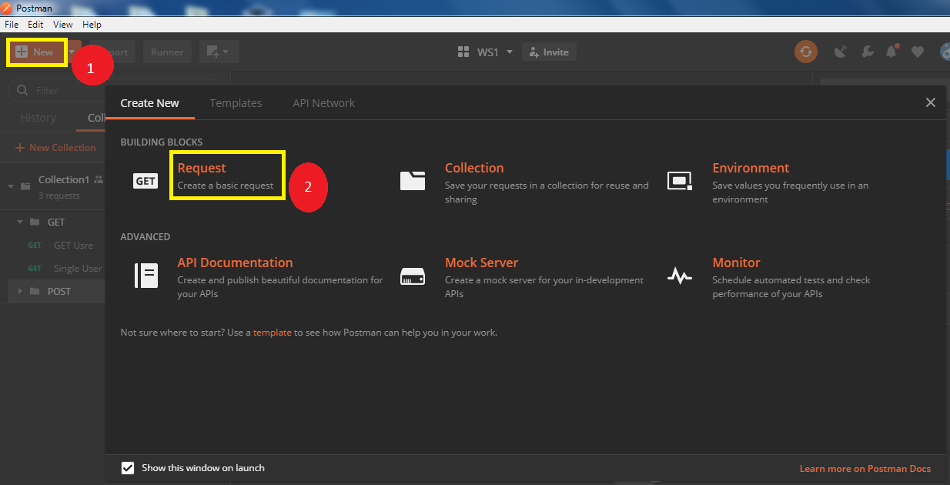

* Set that Request as post
* Set the Body as raw

{

    "email": "eve.holt@reqres.in",

    "password": "pistol"

}

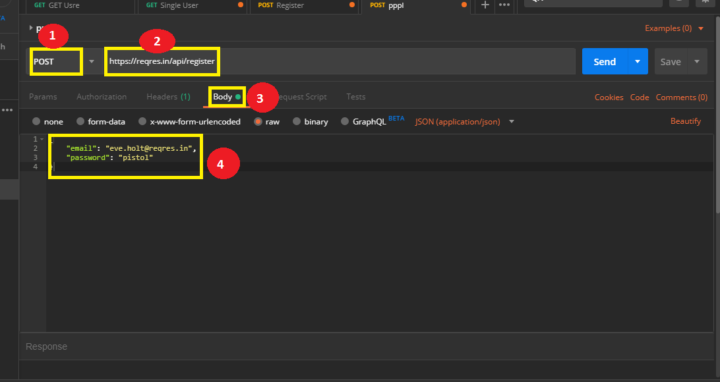

* Set header content type as application/json
* Send the request

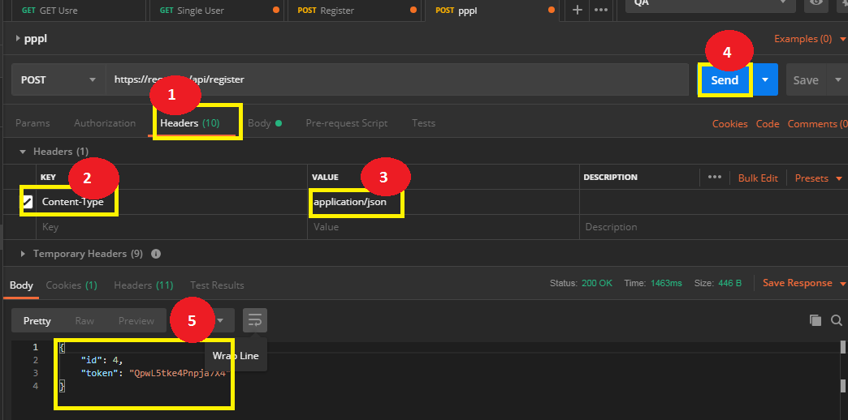

* Consider the request as: <https://reqres.in/api/register/preprod>

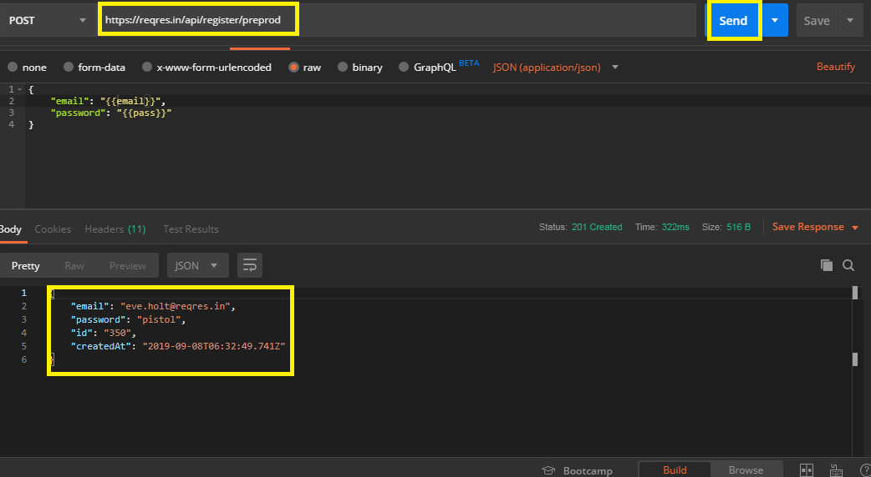

* Create an environment as

*Endpoint=api/register/preprod*

*pass=pistol*

*email=eve.holt@reqres.in*

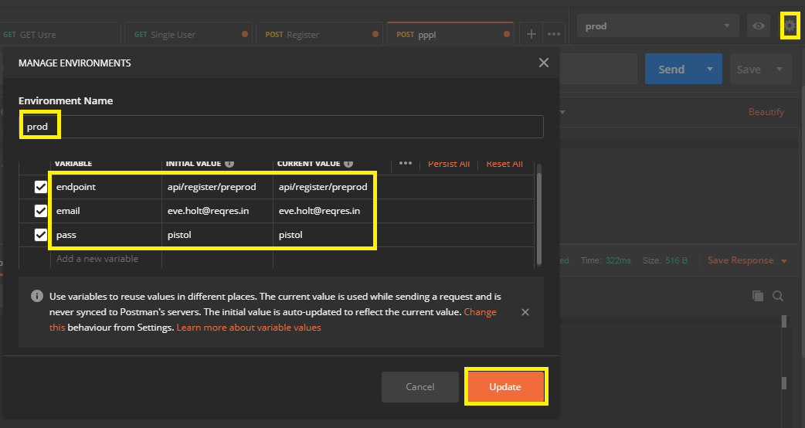

**Step 2.17.2:** Getting the data from CSV file

* Go to desktop, create a text file, and name it as Data.csv
* Write your variables

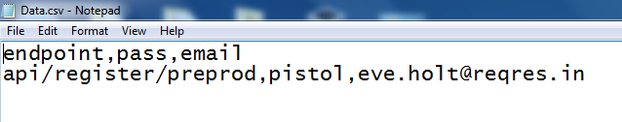

* Run on collection runner
* Select the Data.csv file
* Data file type text/csv
* Click on Run

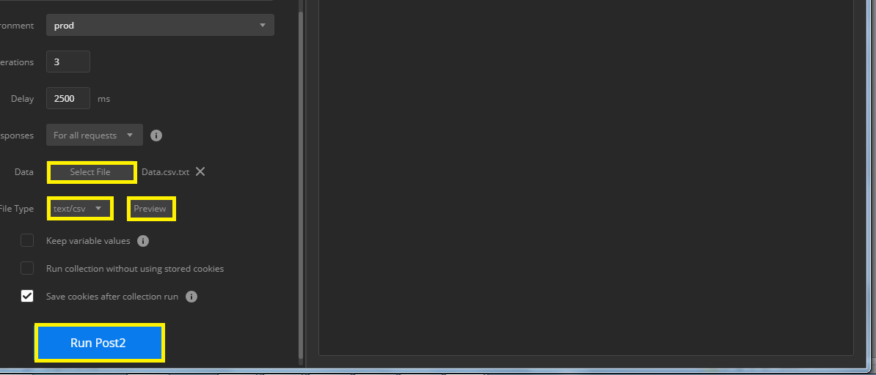

* The output is shown below:

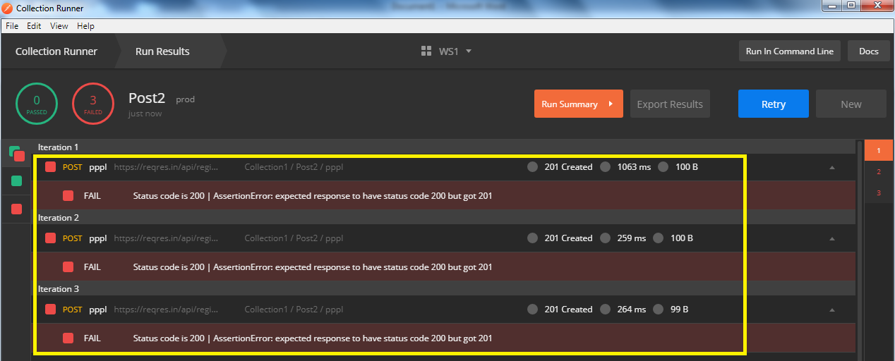

**Step 2.17.3:** Getting the data from JSON file

* Go to desktop, create a text file, and name it as Data1.json
* Write your variables

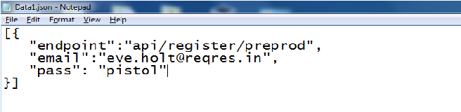

* Run on Collection Runner
* Select the Data1.json file
* Select data file type as application/json
* Click on Run

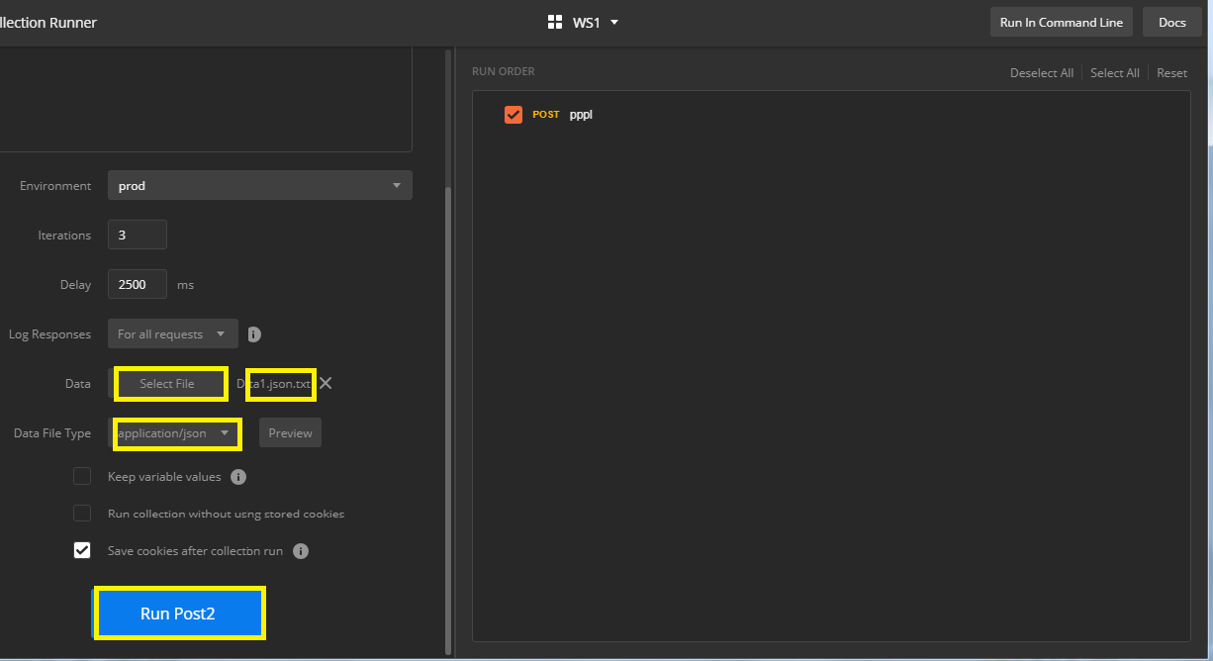

* The output is shown below:

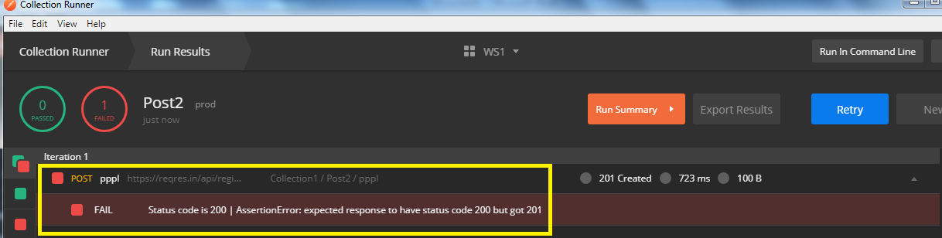

**Step 2.17.4:** Pushing the code to GitHub repositories

Open your command prompt and navigate to the folder where you have created your files

cd <folder path>

Initialize your repository using the following command:

git init

Add all the files to your git repository using the following command:

git add . 

Commit the changes using the following command:

git commit . -m “Changes have been committed.”

Push the files to the folder you initially created using the following command:

git push -u origin master